**Tutorial ISEP VLC testbed**

**Abstract** --VLC with the visible light wavelength from 380nm to 850nm is considered as a complement to RF-based wireless communication since its spectrum is nearly one thousand times larger than RF. It is obviously discovered that VLC can be a valuable complement to the 5G/Beyond 5G (B5G) indoor network in communication.

Based on H2020 IoRL[[1]](https://euc-word-edit.officeapps.live.com/we/wordeditorframe.aspx?ui=en-gb&rs=en-gb&wopisrc=https%3A%2F%2Fiseparis.sharepoint.com%2Fsites%2FFed4Fire%2F_vti_bin%2Fwopi.ashx%2Ffiles%2Ffad05d4bf8cf40adbd70a1ad1f4b57f8&wdenableroaming=1&mscc=1&hid=9e78ea30-ec88-6613-a935-b6584617263a-9564&uiembed=1&uih=teams&uihit=files&hhdr=1&dchat=1&sc=%7B%22pmo%22%3A%22https%3A%2F%2Fteams.microsoft.com%22%2C%22pmshare%22%3Atrue%2C%22surl%22%3A%22%22%2C%22curl%22%3A%22%22%2C%22vurl%22%3A%22%22%2C%22eurl%22%3A%22https%3A%2F%2Fteams.microsoft.com%2Ffiles%2Fapps%2Fcom.microsoft.teams.files%2Ffiles%2F3422756932%2Fopen%3Fagent%3Dpostmessage%26objectUrl%3Dhttps%253A%252F%252Fiseparis.sharepoint.com%252Fsites%252FFed4Fire%252FDocuments%2520partages%252FGeneral%252FTutorial%2520VLC%2520ISEP%2520testbed%2520v2.docx%26fileId%3Dfad05d4b-f8cf-40ad-bd70-a1ad1f4b57f8%26fileType%3Ddocx%26ctx%3Dfiles%26scenarioId%3D9564%26locale%3Den-gb%26theme%3Ddefault%26version%3D21120606800%26setting%3Dring.id%3Ageneral%26setting%3DcreatedTime%3A1648236340312%22%7D&wdorigin=TEAMS-ELECTRON.teams.files&wdhostclicktime=1648236340236&jsapi=1&jsapiver=v1&newsession=1&corrid=2af8b852-4e57-4af3-93eb-380cb3316bcd&usid=2af8b852-4e57-4af3-93eb-380cb3316bcd&sftc=1&sams=1&accloop=1&sdr=6&scnd=1&sat=1&hbcv=1&htv=1&hodflp=1&instantedit=1&wopicomplete=1&wdredirectionreason=Unified_SingleFlush&rct=Medium&ctp=LeastProtected#_ftn1)and H2020 6G BRAINS[[2]](https://euc-word-edit.officeapps.live.com/we/wordeditorframe.aspx?ui=en-gb&rs=en-gb&wopisrc=https%3A%2F%2Fiseparis.sharepoint.com%2Fsites%2FFed4Fire%2F_vti_bin%2Fwopi.ashx%2Ffiles%2Ffad05d4bf8cf40adbd70a1ad1f4b57f8&wdenableroaming=1&mscc=1&hid=9e78ea30-ec88-6613-a935-b6584617263a-9564&uiembed=1&uih=teams&uihit=files&hhdr=1&dchat=1&sc=%7B%22pmo%22%3A%22https%3A%2F%2Fteams.microsoft.com%22%2C%22pmshare%22%3Atrue%2C%22surl%22%3A%22%22%2C%22curl%22%3A%22%22%2C%22vurl%22%3A%22%22%2C%22eurl%22%3A%22https%3A%2F%2Fteams.microsoft.com%2Ffiles%2Fapps%2Fcom.microsoft.teams.files%2Ffiles%2F3422756932%2Fopen%3Fagent%3Dpostmessage%26objectUrl%3Dhttps%253A%252F%252Fiseparis.sharepoint.com%252Fsites%252FFed4Fire%252FDocuments%2520partages%252FGeneral%252FTutorial%2520VLC%2520ISEP%2520testbed%2520v2.docx%26fileId%3Dfad05d4b-f8cf-40ad-bd70-a1ad1f4b57f8%26fileType%3Ddocx%26ctx%3Dfiles%26scenarioId%3D9564%26locale%3Den-gb%26theme%3Ddefault%26version%3D21120606800%26setting%3Dring.id%3Ageneral%26setting%3DcreatedTime%3A1648236340312%22%7D&wdorigin=TEAMS-ELECTRON.teams.files&wdhostclicktime=1648236340236&jsapi=1&jsapiver=v1&newsession=1&corrid=2af8b852-4e57-4af3-93eb-380cb3316bcd&usid=2af8b852-4e57-4af3-93eb-380cb3316bcd&sftc=1&sams=1&accloop=1&sdr=6&scnd=1&sat=1&hbcv=1&htv=1&hodflp=1&instantedit=1&wopicomplete=1&wdredirectionreason=Unified_SingleFlush&rct=Medium&ctp=LeastProtected#_ftn2) research project, ISEP built a Visible Light Communication (VLC) testbed[[3]](https://euc-word-edit.officeapps.live.com/we/wordeditorframe.aspx?ui=en-gb&rs=en-gb&wopisrc=https%3A%2F%2Fiseparis.sharepoint.com%2Fsites%2FFed4Fire%2F_vti_bin%2Fwopi.ashx%2Ffiles%2Ffad05d4bf8cf40adbd70a1ad1f4b57f8&wdenableroaming=1&mscc=1&hid=9e78ea30-ec88-6613-a935-b6584617263a-9564&uiembed=1&uih=teams&uihit=files&hhdr=1&dchat=1&sc=%7B%22pmo%22%3A%22https%3A%2F%2Fteams.microsoft.com%22%2C%22pmshare%22%3Atrue%2C%22surl%22%3A%22%22%2C%22curl%22%3A%22%22%2C%22vurl%22%3A%22%22%2C%22eurl%22%3A%22https%3A%2F%2Fteams.microsoft.com%2Ffiles%2Fapps%2Fcom.microsoft.teams.files%2Ffiles%2F3422756932%2Fopen%3Fagent%3Dpostmessage%26objectUrl%3Dhttps%253A%252F%252Fiseparis.sharepoint.com%252Fsites%252FFed4Fire%252FDocuments%2520partages%252FGeneral%252FTutorial%2520VLC%2520ISEP%2520testbed%2520v2.docx%26fileId%3Dfad05d4b-f8cf-40ad-bd70-a1ad1f4b57f8%26fileType%3Ddocx%26ctx%3Dfiles%26scenarioId%3D9564%26locale%3Den-gb%26theme%3Ddefault%26version%3D21120606800%26setting%3Dring.id%3Ageneral%26setting%3DcreatedTime%3A1648236340312%22%7D&wdorigin=TEAMS-ELECTRON.teams.files&wdhostclicktime=1648236340236&jsapi=1&jsapiver=v1&newsession=1&corrid=2af8b852-4e57-4af3-93eb-380cb3316bcd&usid=2af8b852-4e57-4af3-93eb-380cb3316bcd&sftc=1&sams=1&accloop=1&sdr=6&scnd=1&sat=1&hbcv=1&htv=1&hodflp=1&instantedit=1&wopicomplete=1&wdredirectionreason=Unified_SingleFlush&rct=Medium&ctp=LeastProtected#_ftn3). Two kinds of application currently can be tested: laboratory Optical Wireless Channel（OWC）estimation and an indoor high accuracy positioning application based on visible light. This testbed will be helpful to do different research on different modulation methods, channel coding, channel estimation and physical layer design of VLC systems. Meanwhile, the light-based positioning algorithm and the testbed allow to access to real measured location databases for testing different Artificial Intelligent based positioning algorithm.

**I. Introduction**

With every passing day, our society is becoming more mobile with increasing requirements on data rates and localization accuracy. The major feature in every new emerging electronic product is wireless connectivity providing high data rate, flexibility, mobility and seamless coexistence with existing radio access technology, without the need of expensive wiring infrastructure. Actually, more than 75% of the wireless data traffic is using Wi-Fi indoor access points, while the remaining is covered by classical cellular networks. But these two wireless technologies are facing spectrum congestion, especially WiFi when a huge number of user equipment (UE) are present within a confined indoor space and requesting high traffic services, such as in conference, congress centers or shopping malls. On the other hand, a largely, so-far neglected part of the spectrum is the optical window spanning from infrared into the visible part of the spectrum on to ultra-violet frequencies. We believe that these frequencies are of great importance for future mobile communication solutions beyond 5G, not only due to the huge amount of unregulated spectrum offered, but because of an existing base of mature technology components stemming from fiber and free-space optical communications and synergies that can be exploited by building on existing illumination infrastructures. Visible Light Communication (VLC) is indeed gaining more and more interest due to its very high throughput performance in indoor and its security advantages both for privacy and health. Moreover, LEDs are becoming the predominant light source and could transform in the next coming years any light bulb into a LiFi access point, reducing a lot the extra wired infrastructure needed to implement the backhaul network, but also reducing drastically the user Electro-Magnetic Field (EMF) exposure that today explodes with Wi-Fi and becomes a health concern, as proven by the Loi Abeille promulgated in 2015 in France.

To overcome the aforementioned conventional RF spectrum congestion in indoor and multiusers scenario, under the support of European H2020 research project IoRL, in ISEP we built a Visible light communcation/Position testbed. This systme holds potential to overcome the position’s instability inherent to wireless channel thanks to the most multipath - free propagation brought by VLC. It can achieve decimetre to centimetre precision, using specialized “beaconing LEDs” as landmarks [2]. VLC-IPS can be installed inexpensively since they utilize existing illumination systems with few modifications. It can be used in RF-inappropriate environments, like hospitals, underground mines, and gas stations. Another advantage of VLC-IPS is that there is less effect of multipath on visible light than on RF signal, so the position estimation could be more accurate.

The main objective of the testbed is to provide a realistic visible light positioning testing environment for those experimenters 1) who working on optical wireless access technology. This testbed offers an indoor visible light communication wireless access. It can be used for analyzing and demonstrating that an innovative and data/energy/cost efficient communication system; 2) who working on indoor positioning algorithm and AI based positioning algorithm. The testbed provides a realistic measurement dataset in different indoor environment.

[[1]](https://euc-word-edit.officeapps.live.com/we/wordeditorframe.aspx?ui=en-gb&rs=en-gb&wopisrc=https%3A%2F%2Fiseparis.sharepoint.com%2Fsites%2FFed4Fire%2F_vti_bin%2Fwopi.ashx%2Ffiles%2Ffad05d4bf8cf40adbd70a1ad1f4b57f8&wdenableroaming=1&mscc=1&hid=9e78ea30-ec88-6613-a935-b6584617263a-9564&uiembed=1&uih=teams&uihit=files&hhdr=1&dchat=1&sc=%7B%22pmo%22%3A%22https%3A%2F%2Fteams.microsoft.com%22%2C%22pmshare%22%3Atrue%2C%22surl%22%3A%22%22%2C%22curl%22%3A%22%22%2C%22vurl%22%3A%22%22%2C%22eurl%22%3A%22https%3A%2F%2Fteams.microsoft.com%2Ffiles%2Fapps%2Fcom.microsoft.teams.files%2Ffiles%2F3422756932%2Fopen%3Fagent%3Dpostmessage%26objectUrl%3Dhttps%253A%252F%252Fiseparis.sharepoint.com%252Fsites%252FFed4Fire%252FDocuments%2520partages%252FGeneral%252FTutorial%2520VLC%2520ISEP%2520testbed%2520v2.docx%26fileId%3Dfad05d4b-f8cf-40ad-bd70-a1ad1f4b57f8%26fileType%3Ddocx%26ctx%3Dfiles%26scenarioId%3D9564%26locale%3Den-gb%26theme%3Ddefault%26version%3D21120606800%26setting%3Dring.id%3Ageneral%26setting%3DcreatedTime%3A1648236340312%22%7D&wdorigin=TEAMS-ELECTRON.teams.files&wdhostclicktime=1648236340236&jsapi=1&jsapiver=v1&newsession=1&corrid=2af8b852-4e57-4af3-93eb-380cb3316bcd&usid=2af8b852-4e57-4af3-93eb-380cb3316bcd&sftc=1&sams=1&accloop=1&sdr=6&scnd=1&sat=1&hbcv=1&htv=1&hodflp=1&instantedit=1&wopicomplete=1&wdredirectionreason=Unified_SingleFlush&rct=Medium&ctp=LeastProtected#_ftnref1) [https://iorl.5g-ppp.eu](https://iorl.5g-ppp.eu/)

[[2]](https://euc-word-edit.officeapps.live.com/we/wordeditorframe.aspx?ui=en-gb&rs=en-gb&wopisrc=https%3A%2F%2Fiseparis.sharepoint.com%2Fsites%2FFed4Fire%2F_vti_bin%2Fwopi.ashx%2Ffiles%2Ffad05d4bf8cf40adbd70a1ad1f4b57f8&wdenableroaming=1&mscc=1&hid=9e78ea30-ec88-6613-a935-b6584617263a-9564&uiembed=1&uih=teams&uihit=files&hhdr=1&dchat=1&sc=%7B%22pmo%22%3A%22https%3A%2F%2Fteams.microsoft.com%22%2C%22pmshare%22%3Atrue%2C%22surl%22%3A%22%22%2C%22curl%22%3A%22%22%2C%22vurl%22%3A%22%22%2C%22eurl%22%3A%22https%3A%2F%2Fteams.microsoft.com%2Ffiles%2Fapps%2Fcom.microsoft.teams.files%2Ffiles%2F3422756932%2Fopen%3Fagent%3Dpostmessage%26objectUrl%3Dhttps%253A%252F%252Fiseparis.sharepoint.com%252Fsites%252FFed4Fire%252FDocuments%2520partages%252FGeneral%252FTutorial%2520VLC%2520ISEP%2520testbed%2520v2.docx%26fileId%3Dfad05d4b-f8cf-40ad-bd70-a1ad1f4b57f8%26fileType%3Ddocx%26ctx%3Dfiles%26scenarioId%3D9564%26locale%3Den-gb%26theme%3Ddefault%26version%3D21120606800%26setting%3Dring.id%3Ageneral%26setting%3DcreatedTime%3A1648236340312%22%7D&wdorigin=TEAMS-ELECTRON.teams.files&wdhostclicktime=1648236340236&jsapi=1&jsapiver=v1&newsession=1&corrid=2af8b852-4e57-4af3-93eb-380cb3316bcd&usid=2af8b852-4e57-4af3-93eb-380cb3316bcd&sftc=1&sams=1&accloop=1&sdr=6&scnd=1&sat=1&hbcv=1&htv=1&hodflp=1&instantedit=1&wopicomplete=1&wdredirectionreason=Unified_SingleFlush&rct=Medium&ctp=LeastProtected#_ftnref2) <https://6g-brains.eu>

[[3]](https://euc-word-edit.officeapps.live.com/we/wordeditorframe.aspx?ui=en-gb&rs=en-gb&wopisrc=https%3A%2F%2Fiseparis.sharepoint.com%2Fsites%2FFed4Fire%2F_vti_bin%2Fwopi.ashx%2Ffiles%2Ffad05d4bf8cf40adbd70a1ad1f4b57f8&wdenableroaming=1&mscc=1&hid=9e78ea30-ec88-6613-a935-b6584617263a-9564&uiembed=1&uih=teams&uihit=files&hhdr=1&dchat=1&sc=%7B%22pmo%22%3A%22https%3A%2F%2Fteams.microsoft.com%22%2C%22pmshare%22%3Atrue%2C%22surl%22%3A%22%22%2C%22curl%22%3A%22%22%2C%22vurl%22%3A%22%22%2C%22eurl%22%3A%22https%3A%2F%2Fteams.microsoft.com%2Ffiles%2Fapps%2Fcom.microsoft.teams.files%2Ffiles%2F3422756932%2Fopen%3Fagent%3Dpostmessage%26objectUrl%3Dhttps%253A%252F%252Fiseparis.sharepoint.com%252Fsites%252FFed4Fire%252FDocuments%2520partages%252FGeneral%252FTutorial%2520VLC%2520ISEP%2520testbed%2520v2.docx%26fileId%3Dfad05d4b-f8cf-40ad-bd70-a1ad1f4b57f8%26fileType%3Ddocx%26ctx%3Dfiles%26scenarioId%3D9564%26locale%3Den-gb%26theme%3Ddefault%26version%3D21120606800%26setting%3Dring.id%3Ageneral%26setting%3DcreatedTime%3A1648236340312%22%7D&wdorigin=TEAMS-ELECTRON.teams.files&wdhostclicktime=1648236340236&jsapi=1&jsapiver=v1&newsession=1&corrid=2af8b852-4e57-4af3-93eb-380cb3316bcd&usid=2af8b852-4e57-4af3-93eb-380cb3316bcd&sftc=1&sams=1&accloop=1&sdr=6&scnd=1&sat=1&hbcv=1&htv=1&hodflp=1&instantedit=1&wopicomplete=1&wdredirectionreason=Unified_SingleFlush&rct=Medium&ctp=LeastProtected#_ftnref3) <http://zhangxun.free.fr/project/sdrl/>

**II. Description of the testbed**

The testbed contains **4** main components for VLC measurement campaign as shown in the figure below.

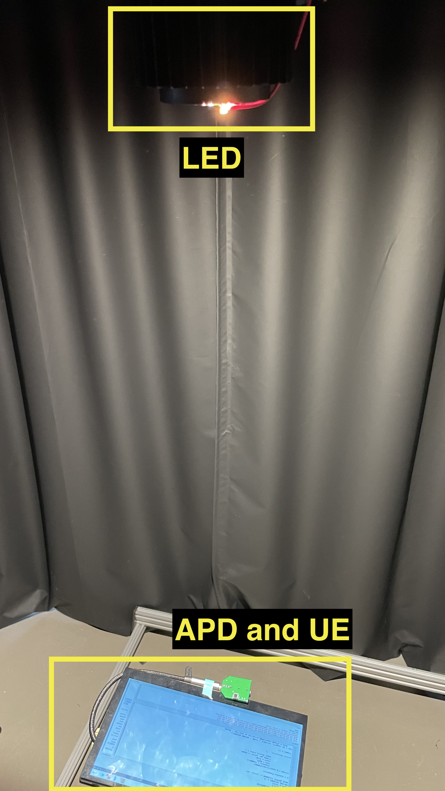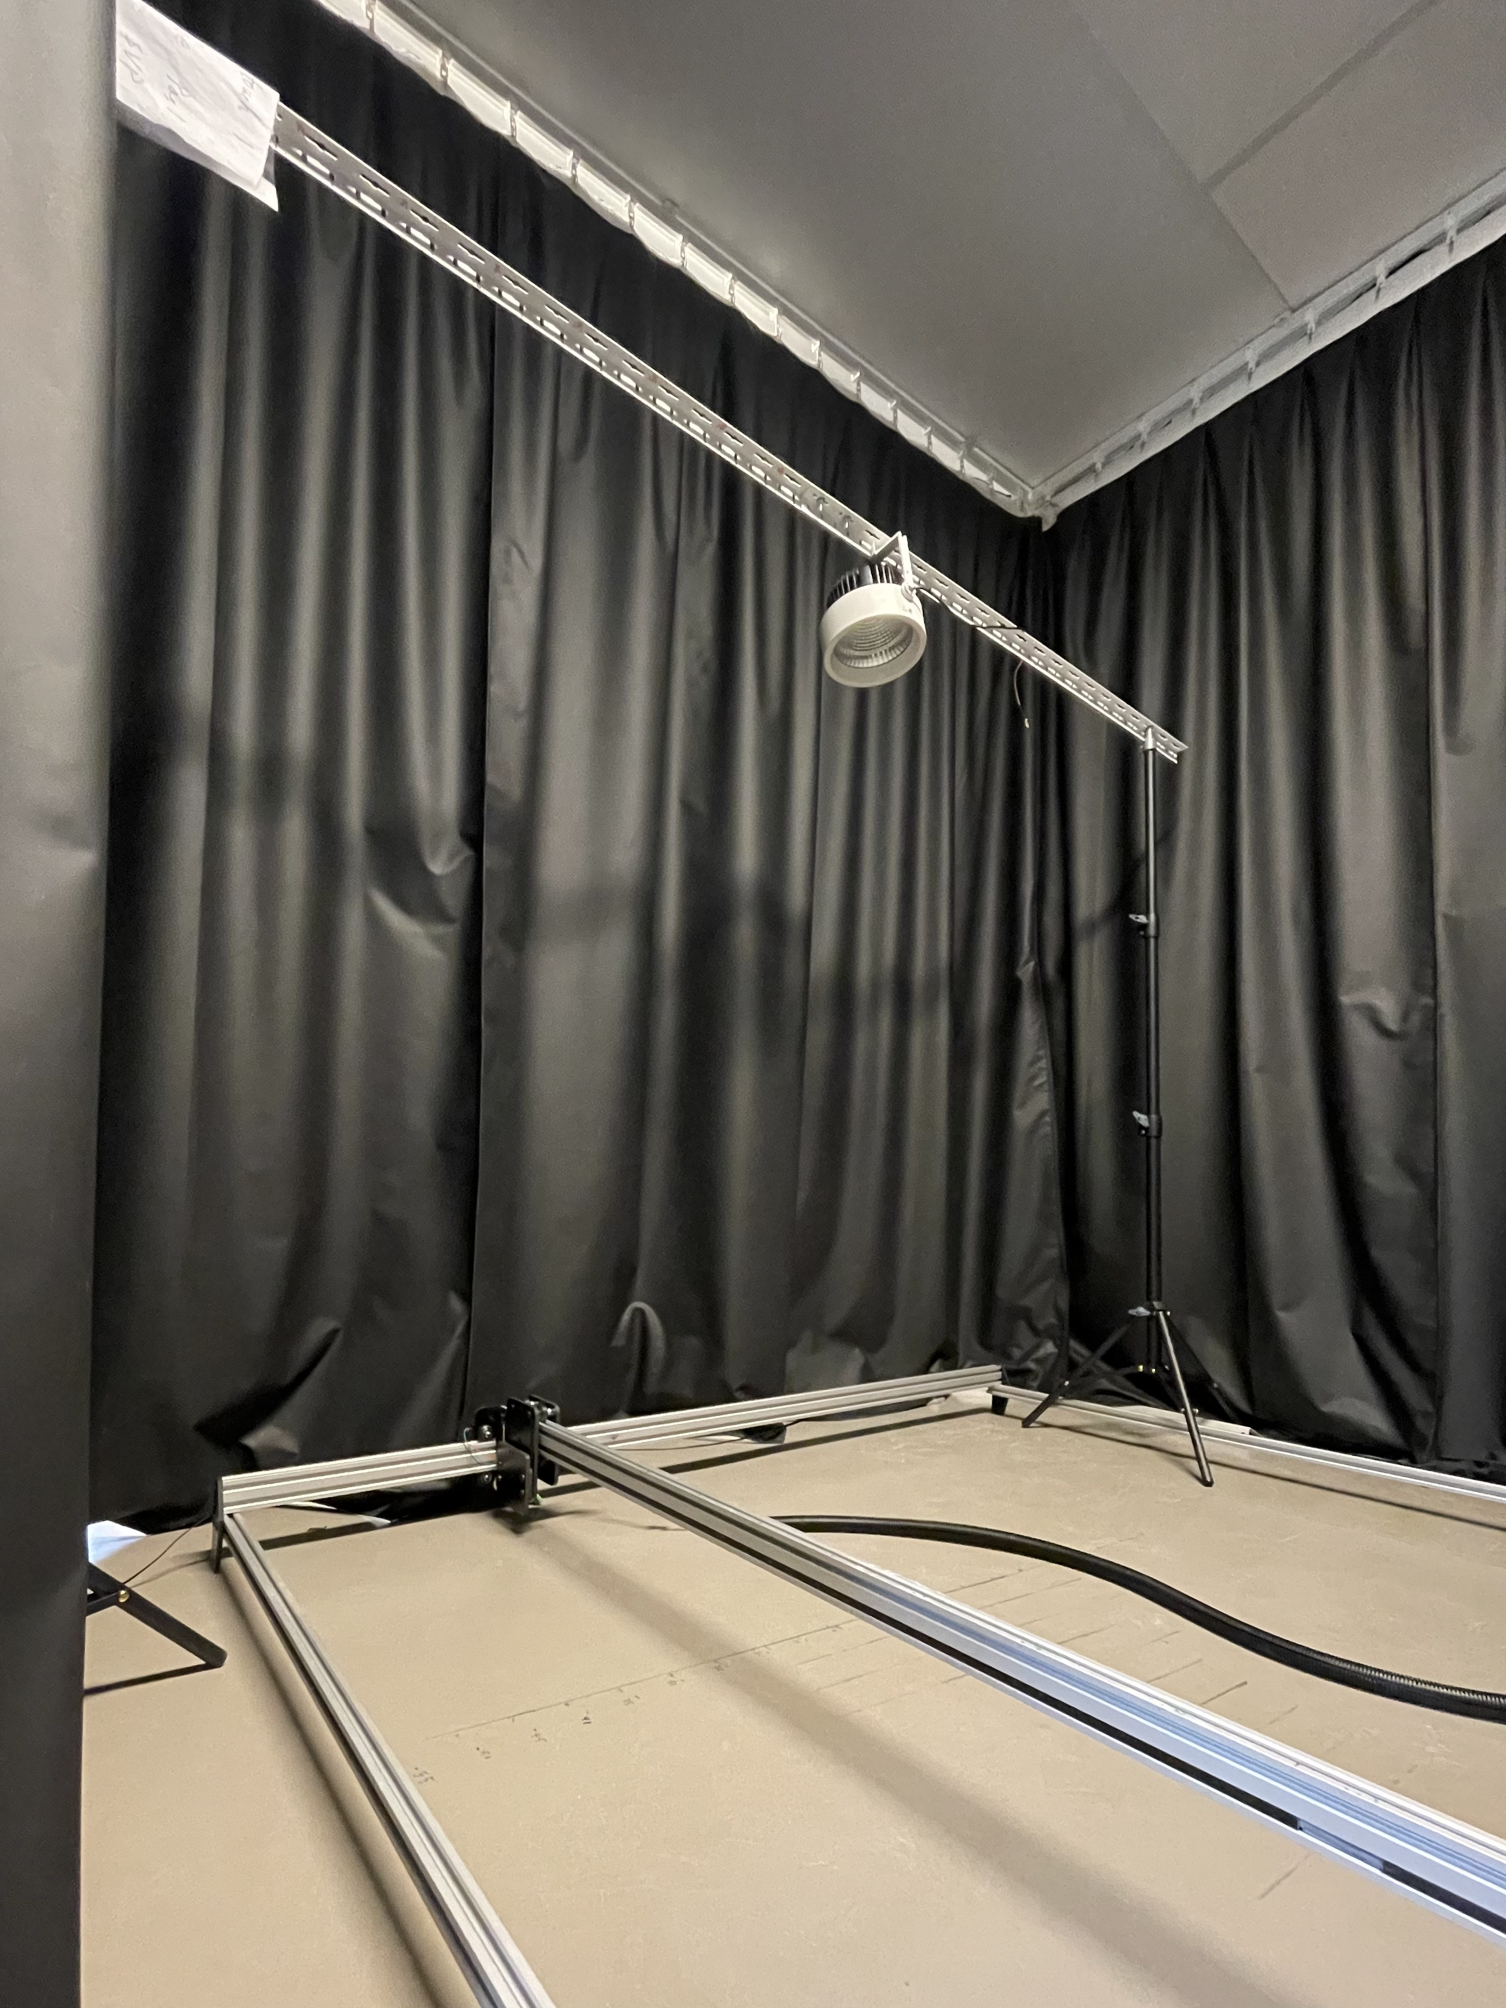

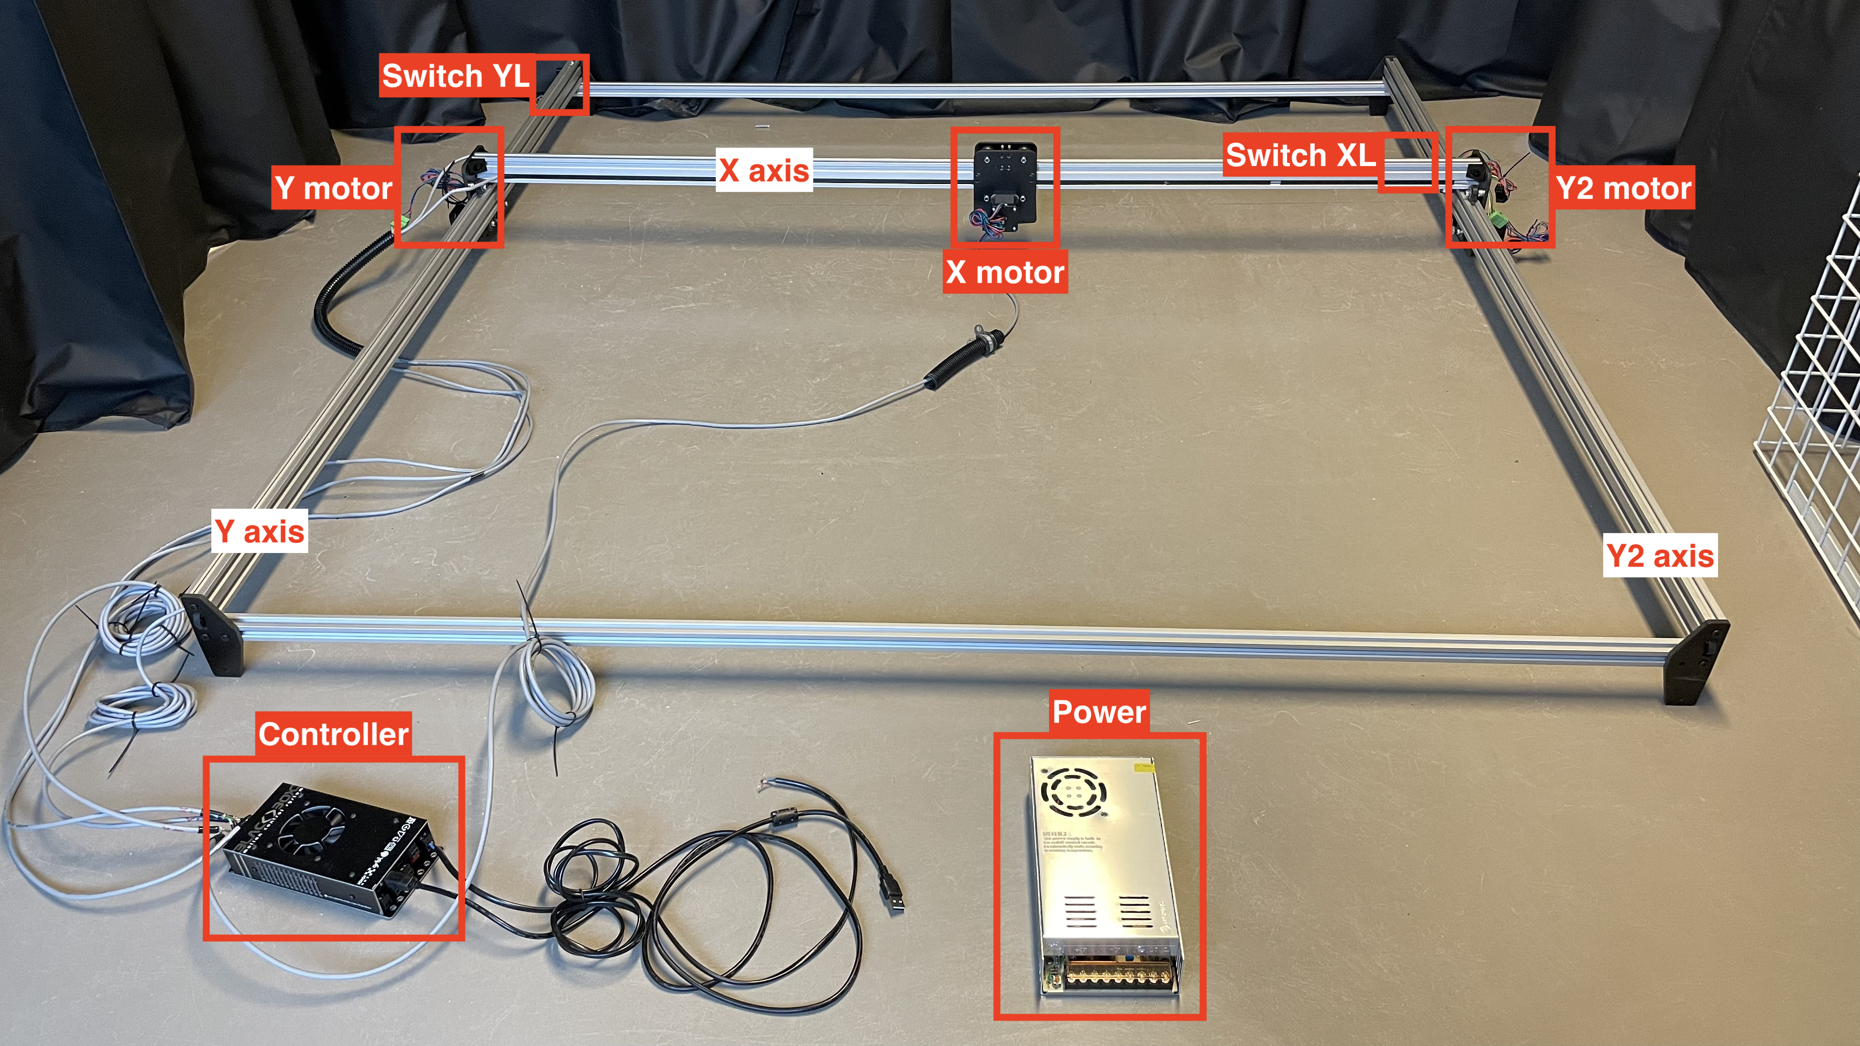

1) **A 5G base station (server)** including PHY Layer Central Unit, named DRAN (Distributed Radio Access Network) and RRLH Control Units. DRAN is carrying out the tasks of the L1 upper layer, which mainly include the FEC encoding and decoding, beam management, distribution of the data to the RRLHs over the 10 Gbps Ethernet rings and the interface with the MAC and higher layers. RRLH Control Units are responsible for the major part of the PHY layer processing. Processing includes mainly the data modulation/ demodulation, precoding, IFFT, air interface resource mapping, and antenna/LED management. These units’ interface on one side with the 10 Gbps Ethernet rings and on its other, via the D/A and A/D, side with the VLC modules through a switch and/or splitter/combiner. Our Visible Light Positioning (VLP) applications is shown in the figure below is implemented on the client. The opensource code can be found in <https://github.com/VLPISEP/GUIofVLP>. The users should install this GUI to use the testbed.

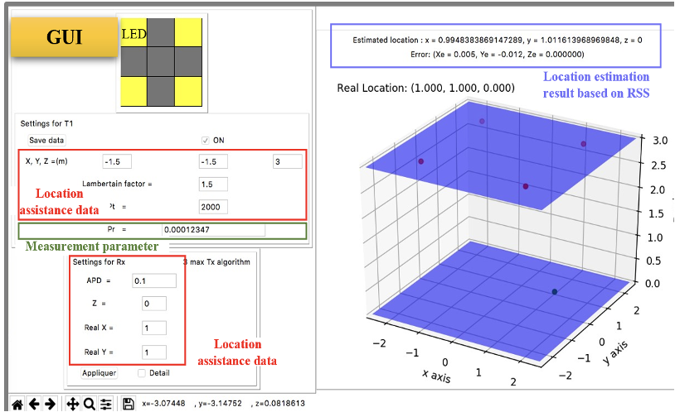

the GUI of VLP application

In this GUI interface, User can set different Location assistance data like:

Indoor environment parameter:

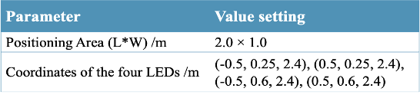

On the right side of the GUI, a 3D model is shown which can print out the results of the positioning. At the same time, to manage the positioning data, a database is established to store all the positioning information. The behavior diagram and the structure diagram of the VLP application are shown in the figure below. Step by Step installation of GUI explained in the next section of the file.

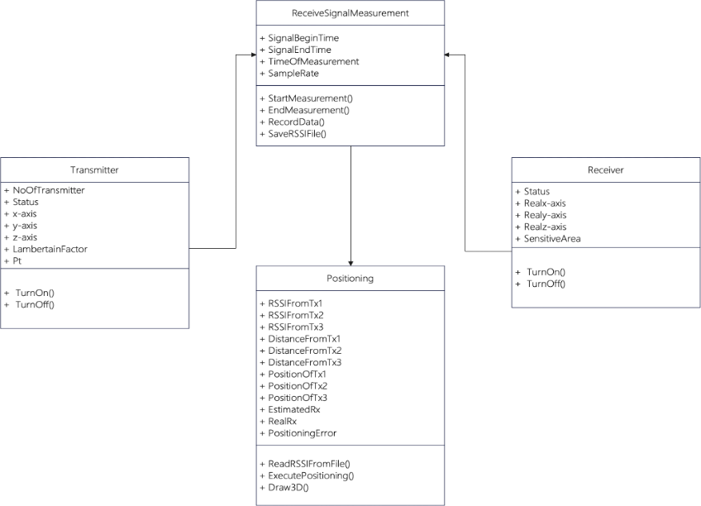

2) **A user equipment** including a 5G NR baseband processing server hosts a signal analysing software and a USRP. This 5G NR baseband software can process the received signal from the USRP and perform the OFDM demodulation, channel estimation and zero forcing equalization to obtain the symbols. The USRP device connects to the 5G NR baseband processing server through 2*10 Gigabit cable. The USRP device handles the input signal from the VLC RX module. It converts the received 3.48 GHz IF signal to baseband signal and delivers to the data processing server.

3) **VLC Tx/Rx modules.** This includes APD and UE and AED. Parameter of Transmitter and Receiver are found below:

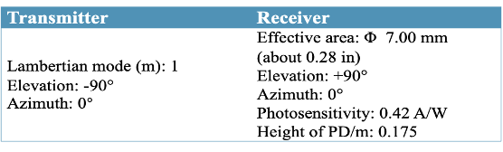

4) **USRP device:** 10MHz reference signal is provided to the 13GHz LO generator and the USRP device separately.

The main hardware in this testbed is listed in the table below and the total estimated cost is 102Keuro:

|  |
| --- |
| Material |
| Keysight N9010B EXA signal analyzer |
| Keysight RF vector signal generator |
| LED driver PCB design and fabrication |
| Mechanism rail and OpenBuilds ACRO system |
| Thorlabs optical rail |
| USRP R2920 x2 with Labview license |
| PXI controller without PC to connect with USRP |

The system setup parameters including the power levels, modulation schemes, bandwidth, and carrier frequencies of these four main components are configured separately for the VLC measurement campaign.

As for the VLC link, RRLH generates a signal with centre IF frequency of 15 MHz and power of around -43 dBm from 15 MHz RF port. Then the signal is amplified to a proper power level and spitted by the switch into 4 VLC panels. The red coloured line in above diagram represents RF cable with SMA connector. The VLC modulator inside each VLC panel is designed to accept at much higher input power. Generally, the higher input power the between signal quality is for VLC modulator. However, there is protective input power for VLC to prevent VLC modulator being damaged. So, input power to VLC panel should be no more than -6 dBm. In order to achieve good signal quality, two stage amplifiers are required to provide -6 dBm power level signal to VLC panel. In addition, to cope with uncertain cable attenuation, an adjustable attenuator is plugged between the two amplifiers.

**III. GUI installation**

# **Install testbed_rss_gui**

# Install dependencies:

pip install numpy matplotlib scipy tkinter PIL re csv

## **Using GUI in command line**

python3 tk_main.py

## **To connect Raspbery Pi by SSH (The pdf version of this tutorial is in the root directory）**

Settings in RaspberryPi 1.1 Install the wifi module Because there is no wifi connection module in Raspberry Pi, so each time when it is reboot, a wifi module have to be download with a wired network with wire network is connected:

sudo dhcpcd -4

Then the Pi can successfully connect to a wifi network. 1.2 Connect Pi in a local area network by wifi Don’t forget to write down the ip address of the Raspberry Pi (e.g. 172.29.18.245). Can use a command to know the detail:

ipconfig

Settings in PC 2.1 Connect the pc to the local area network where the raspberry pi is located 2.2 PuTTY configuration Firstly make sure PuTTY is installed on the PC. Then in ‘PuTTY SSH Client’ application, input the ip address of Raspberry Pi (e.g. 172.29.18.245) and the username/password.

```  
Port: 22  
Connection type: SSH  
Close window on exit: Only on clean exit

Username: pi Password: raspberry

Then the PC is successfully connected with the Pi.  
   
Using graphical interface of Pi in PC  
If we want to use the graphical interface of Pi, a VNC server application is needed. Download this application in PC and Pi, use the ip address of Raspberry Pi (e.g. 172.29.18.245) , username and password can make the connection:  
  
Username: pi  
Password: raspberry  
  
Then the graphical interface of Pi can be shown on PC.  
  
  
Shared folders between Pi and PC  
4.1 Specify a folder to share  
 Specify a folder in Pi in : /home, such as: /home/pi/output  
4.2 Upload settings  
 In Raspberry Pi, execute following commands:

sudo nano/etc/samba/smb.conf

In this config file, add following contents at the end of the file:  
   
 [Pi_output]  
 path = /home/pi/output  
 read only = no  
 public = yes  
 writable =yes  
  
 Then save and quit.

4.3 Check shared folders in PC  
 With the connection of PuTTY, open the network in the file management. find the ‘raspberry’ folder. This folder represents documents in Raspberry Pi. In ubuntu, input the file path with the ip address of Pi (e.g. 172.29.18.245):   
   
 smb://172.29.18.245  
  
Open it, the shared folder ‘Pi_output’ can be found. The two folders are synchronized, any modification and deletion will take effect on both devices at the same time.

**IV. Publications**

The testbed has been built under the support of H2020 IoRL research project which has been finished at the end of 2020. Currently, this testbed is open for different master/engineering student project and also for our European scientifical research partners. Meanwhile, this testbed is also integrated in engineering academic learning track “IoT and electronic system” (code: IE.2307) in ISEP (40 students per year).

The corresponding works have been published in different journal and conference papers. Some selected publications are shown here, in which the corresponding hardware and software GUI are presented:

[1] Lina Shi , Dayu Shi, Xun Zhang , Benjamin Meunier, Hequn Zhang , Zhan Wang, Andrei Vladimirescu, Wei Li, Yue Zhang, John Cosmas, Kareem Ali, Nawar Jawad , Rudolf Zetik, Eric Legale, Matteo Satta, Jintao Wang , and Jian Song “5G Internet of Radio Light Positioning System for Indoor Broadcasting Service” IEEE TRANSACTIONS ON BROADCASTING, VOL. 66, NO. 2, JUNE 2020

[2] Kareem Ali, John Cosmas, Yue Zhang, Hequn Zhang, Ben Meunier, Nawar Jawad, Xun Zhang, Lina Shi, James Gbadamosi, Atanas Savov , [**Measurement Campaign on 5G Indoor Millimeter Wave and Visible Light Communications Multi Component Carrier System**](https://ieeexplore.ieee.org/abstract/document/9598900/)**,** IEEE TRANSACTIONS ON BROADCASTING,, November 2021

[3]Lina Shi, Xun Zhang, Andrei Vladimirescu, Zhan Wang, Yue Zhang, Jintao Wang, Jorge Garcia, John Cosmas, Adam Kapovits, [**Experimental testbed for VLC-based localization framework in 5G Internet of Radio Light**](https://ieeexplore.ieee.org/abstract/document/8964680/)**,** 2019 26th IEEE International Conference on Electronics, Circuits and Systems (ICECS)